1. **INTRODUCTION**

# Project Overview

As our lives are very busy these days, we often feel we need more than 24 hrs. a day to cope up with everything we have in our schedule. Well, that's not possible but reducing the time by changing the conventional method of reading news can help. Just tell us what market news you're interested in and get a quick peek for the day. Only read what you feel is relevant and save your time. This app helps you to query for all information about Indices, Commodities, Currencies, Future Rates, Bonds, etc.

# Purpose :

Newspapers are one of the most popular and most needed commodities in our daily life. In today's busy world, reading newspapers has become one of the traditional ways of getting news. News is produced every minute and distributed via television, radio and the Internet, so the news updated the next morning is already outdated. So newspaper and magazine publishers have a hard time keeping up with the pace. Change is needed and publishers must embrace mobile.

# LITERATURE SURVEY

* 1. **References**

1. https://flask.palletsprojects.com/en/2.1.x/tutorial/
2. https://[www.ibm.com/docs/en/db2-for-zos/11?topic=zos-db2-basics-tutorial-working-db2-interactively](http://www.ibm.com/docs/en/db2-for-zos/11?topic=zos-db2-basics-tutorial-working-db2-interactively) 3.https://[www.ibm.com/in-en/products/watson-assistant/docs-resources](http://www.ibm.com/in-en/products/watson-assistant/docs-resources) 4.https://[www.ibm.com/blogs/cloud-archive/2019/03/video-containerization-explained/](http://www.ibm.com/blogs/cloud-archive/2019/03/video-containerization-explained/) 5.https://developer.ibm.com/components/cloud-foundry/tutorials/

# Problem Statement Definition

In today’s world we have a lot of work and there is no time to cope up everything in the schedule. So, it is not possible to read the newspaper. By using this application, the user can access the news they are interested and get a quick peek for the day. There are multiple news-sharing apps used by a single user and are often spammed with notifications. There is also a lot of fake news which gets shared. A news- sharing app wants to help users find relevant and important news easily every day and also understand

explicitly that the news is not fake but from proper sources. This news tracker application helps the user to get all information about commodities, sports, technology, education etc. The user can register using their personal details and interacts with the application and save their time. • Creating an app that benefits with the smart news filtering functionality where it allows its users to segregate various news sections, comprising of business, sports, political, international, and more. The users can opt for filters like Breaking News, Most Popular, and more. • Creating a user-friendly news app that would not just have good number of features, but will also be able to get accessed by different types of users keeping the experience delightful

# IDEATION & PROPOSED SOLUTION

* 1. **Empathy Map Canvas**

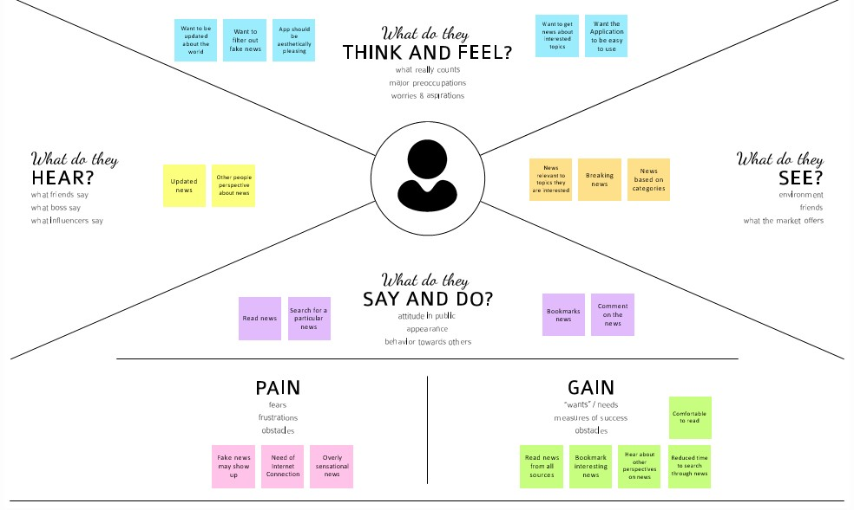

# Ideation & Brainstorming

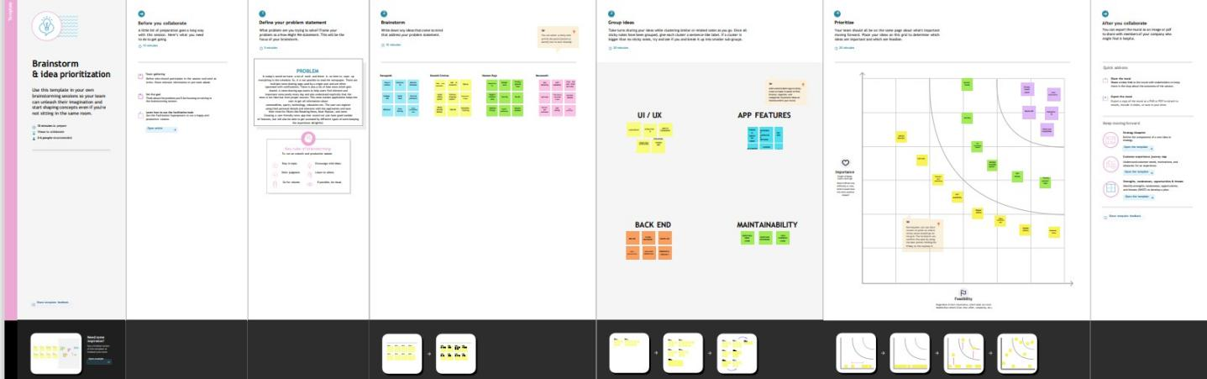

* 1. **Proposed Solution**

|  |  |  |
| --- | --- | --- |
| S.NO | Parameter | Description |
| 1 | Problem Statement (Problem to be solved) | Statement: Everyday, a lot of events happen world-wide and we rely on newspapers, television and news articles to get the reliable and trust-worthy information about these events. Description: As a result, we created a platform that offers such news from reliable sources worldwide, in an organized and efficient manner. |
| 2 | Idea / Solution description | One platform for all local and worldwide news. Trustworthy and Reliable News. Fast and efficient system. Preventing spread of False information. Data Storage and Backup. Communication. |
| 3 | Novelty / Uniqueness | A cloud computing-based news application that generates news and reports about the happenings around the world using computers and network (Internet). News based on most reliable and trustworthy resources around the world. Developing the Eco- Friendly & sustainability based on centre. |
| 4 | Social Impact / Customer Satisfaction | Cloud computing offers a way to create, coordinate, and share information across the globe. The adoption of cloud-based services  gives access to a wider range of data and sharing the important |

|  |  |  |
| --- | --- | --- |
|  |  | information in an efficient way. Our platform eliminates the spread of false news and exposes the injustice and wrongdoings done by false groups. Eliminating the fake news provides better understanding of the real-events happening in the world and the spread of knowledge. |
| 5 | Business Model (Revenue Model) | Our application covers a range of topics including politics, business, criminal justice, environment, technology etc. Our business model will be monetized and generate income by showing advertisements and Operating on monthly and yearly subscription model. |
| 6 | Scalability of the Solution | Scalability is one of the benchmarks of the cloud services and its adoption with businesses. Cloud scalability will help to increase the user base by increasing the resource allocation and meeting the changing demands without sacrificing the efficiency or quality of our customer service and internal operations. Providing fast and reliable news while maintaining positive relationships with your customers. |

# Problem Solution fit

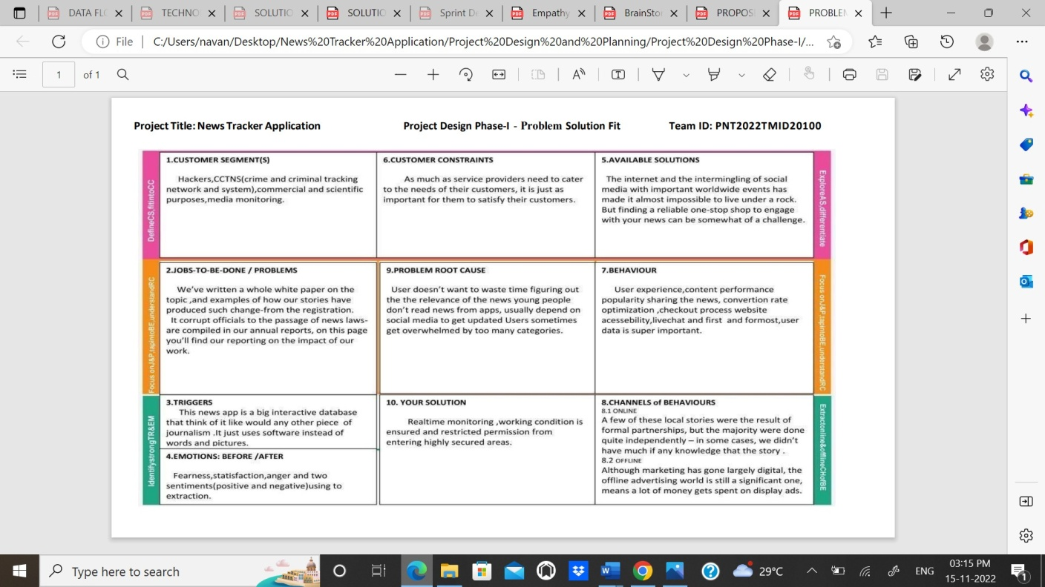

1. **REQUIREMENT ANALYSIS**

# Functional requirement

|  |  |  |
| --- | --- | --- |
| FR No. | Functional Requirement (Epic) | Sub Requirement (Story / Sub- Task) |
| FR-1 | User Installation | User can install the app from Google play store or from the website |
| FR-2 | User Registration | Registration through Form Registration through Gmail |
| FR-3 | User Confirmation | Confirmation via Email |
| FR-4 | User Login | User should login the app with the user's name and password |

* 1. **Non-Functional requirements**

|  |  |  |
| --- | --- | --- |
| FR No | Non-Functional Requirement | Description |
| NFR-1 | Usability | Everyone can understand the process of using the app easily by the commands given in the app |
| NFR-2 | Security | It is a more secured app. No fake news can be shared. |
| NFR-3 | Performance | Performance of the app is very great |
| NFR-4 | Availability | More sub categories are available |

# PROJECT DESIGN

**5.1Data Flow Diagrams**

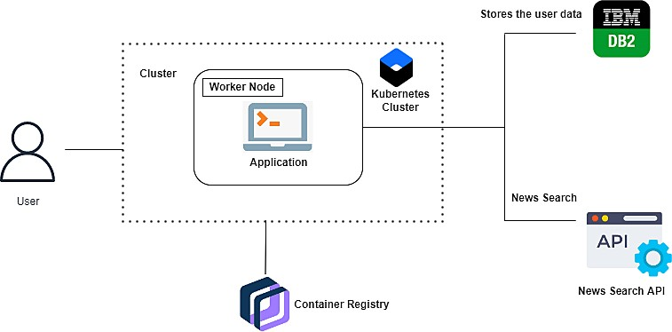

# Solution & Technical Architecture

* + - The user interacts with the application.
    - Registers by giving the details.
    - Integrate the application with news APIs and store the data in the database.
    - The database will have all the details and the user can search the news by using a search bar.

# User Stories

As our lives are very busy these days, we often feel we need more than 24 hrs. a day to cope up with everything we have in our schedule. Well, that's not possible but reducing the time by changing the conventional method of reading news can help. Just tell us what market news you're interested in and get a quick peek for the day. Only read what you feel is relevant and save your time. This app helps you to query for all information about Indices, Commodities, Currencies, Future Rates, Bonds, etc.… as on official websites.

# PROJECT PLANNING & SCHEDULING

* 1. **Sprint Planning & Estimation**

|  |  |  |  |  |  |  |
| --- | --- | --- | --- | --- | --- | --- |
| Sprint | Functional Requirement (Epic) | User Story Numbe | User Story / Task | Story Points | Priority | Team Members |
| Sprint-1 | Registration | USN-1 | As a user, I can register for the application by entering my email, password, and confirming Kowisck Srinivas my password. | 2 | High | Balaji R  Eswaran S  Kavinkumar S  Mohammed Ibrahim M |
| Sprint-1 |  | USN-2 | s a user, I will receive confirmation email once I have registered for the application | 1 | High | Balaji R  Eswaran S  Kavinkumar S  Mohammed Ibrahim M |
| Sprint-2 |  | USN-3 | As a user, I can register for the application through Facebook | 2 | Low | Balaji R  Eswaran S  Kavinkumar S  Mohammed Ibrahim M |
| Sprint-1 |  | USN-4 | As a user, I can register for the application through Gmail | 2 | Medium | Balaji R  Eswaran S  Kavinkumar S  Mohammed Ibrahim M |
| Sprint=1 | Login | USN-5 | As a user, I can log into the application by entering email & password | 1 | High | Balaji R  Eswaran S  Kavinkumar S  Mohammed Ibrahim M |

|  |  |  |  |  |  |  |
| --- | --- | --- | --- | --- | --- | --- |
|  |  |  |  |  |  |  |
| Sprint-3 | Dashboard | USN-6 | As a user, I will able to see the login and profile details | 2 | Medium | Balaji R  Eswaran S  Kavinkumar S  Mohammed Ibrahim M |
| Sprint-1 | IBM cloud | USN-10 | As a tracker, I collect all the NEWS from the cloud | 1 | Medium | Balaji R  Eswaran S  Kavinkumar S  Mohammed Ibrahim M |
| Sprint-3 | IBM cloudant | USN-11 | As a database manager, I can collect all the user details and NEWS application details | 2 | Medium | Balaji R  Eswaran S  Kavinkumar S  Mohammed Ibrahim M |

# Sprint Delivery Schedule

|  |  |  |  |  |  |  |
| --- | --- | --- | --- | --- | --- | --- |
| Sprint | Total Story Points | Duration | Sprint Start Date | Sprint End Date (Planned) | Story Points Completed (as on Planned End Date) | Sprint Release Date (Actual) |
| Sprint-1 | 20 | 6 Days | 24 Oct 2022 | 29 Oct 2022 | 20 | 29 Oct 2022 |
| Sprint-2 | 20 | 6 Days | 31 Oct 2022 | 05 Nov 2022 | 20 | 05 Nov 2022 |
| Sprint-3 | 20 | 6 Days | 07 Nov 2022 | 12 Nov 2022 | 20 | 12 Nov 2022 |
| Sprint-4 | 20 | 6 Days | 14 Nov 2022 | 19 Nov 2022 | 20 | 19 Nov 2022 |

* 1. **Reports from JIRA Sprit-1**

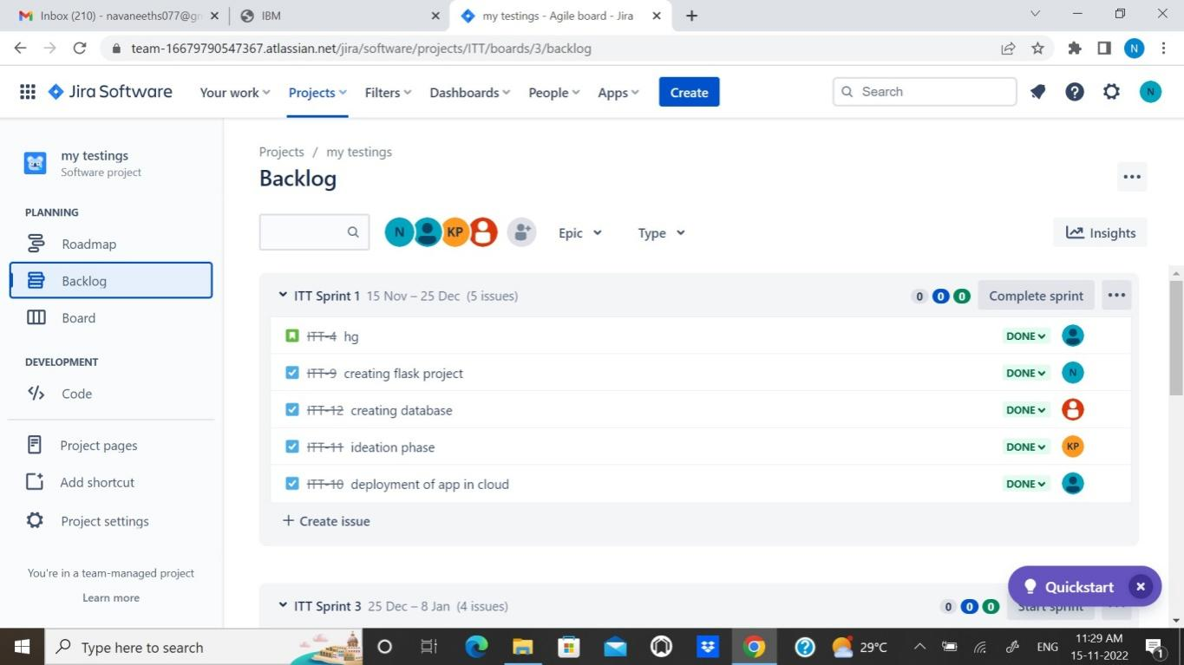

# Sprint-2

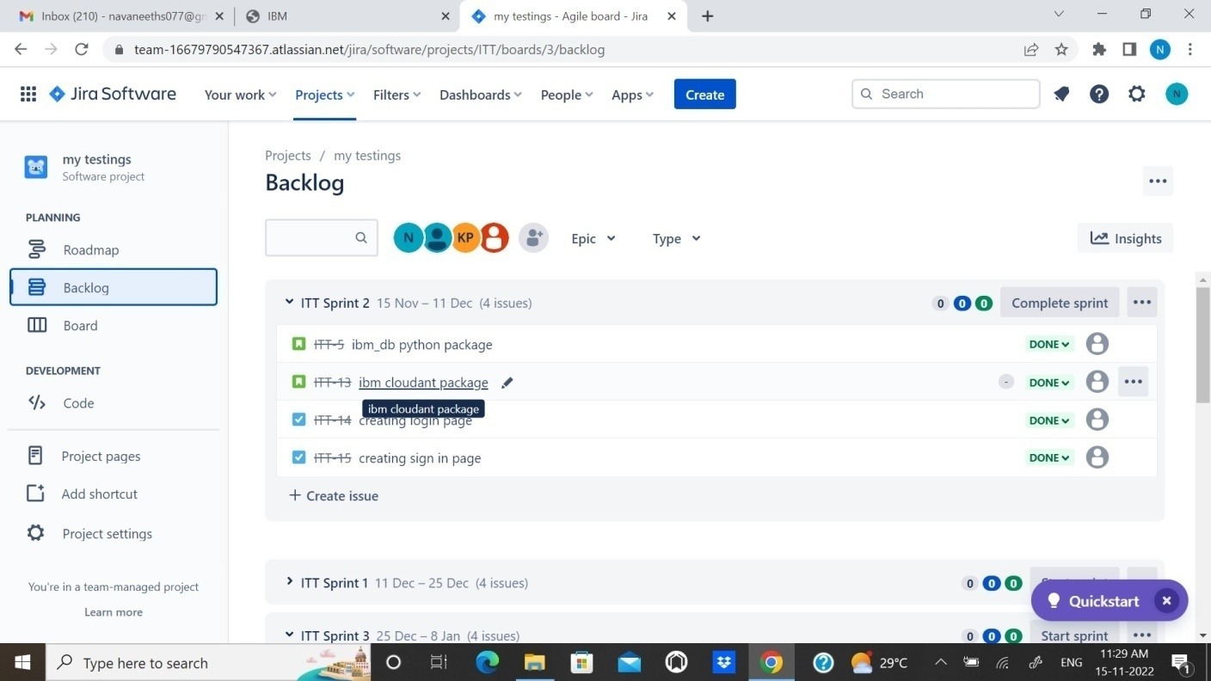

**Sprint-3**

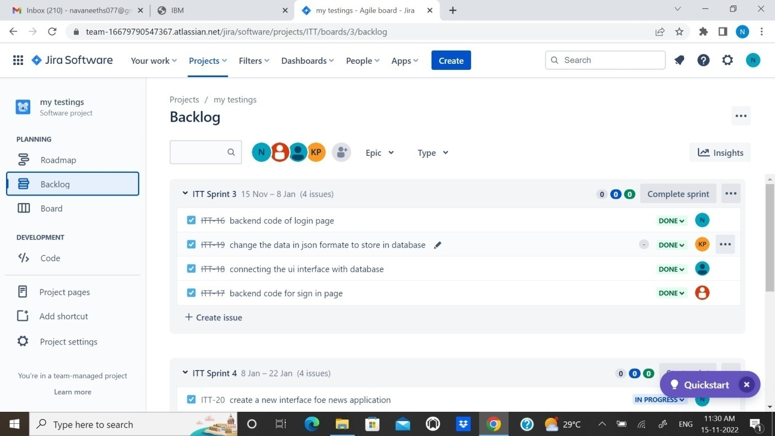

# Sprint-4

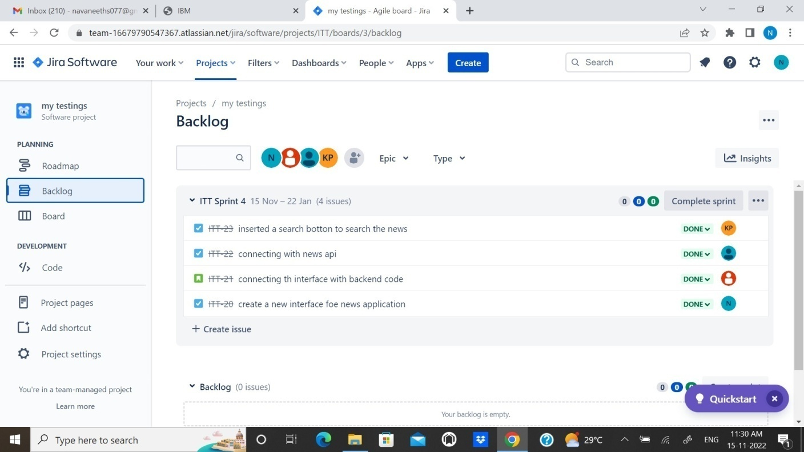

1. **CODING & SOLUTIONING**

# 7.1Feature 1

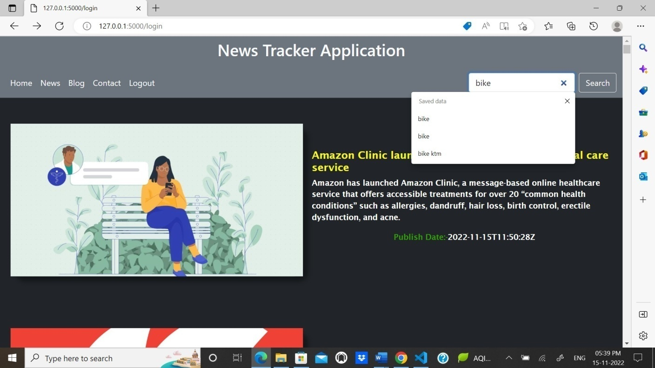

1. **TESTING**

# User Acceptance Testing:

|  |  |
| --- | --- |
| TEAM ID | PNT2022TMID30960 |
| TEAM LEADER | DeviPriya S |
| PROJECT NAME | News Trecker Application |

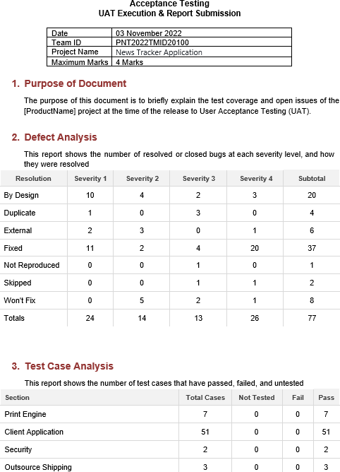

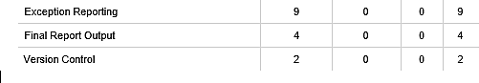

1. **RESULTS**

# 9.1Performance Metrics

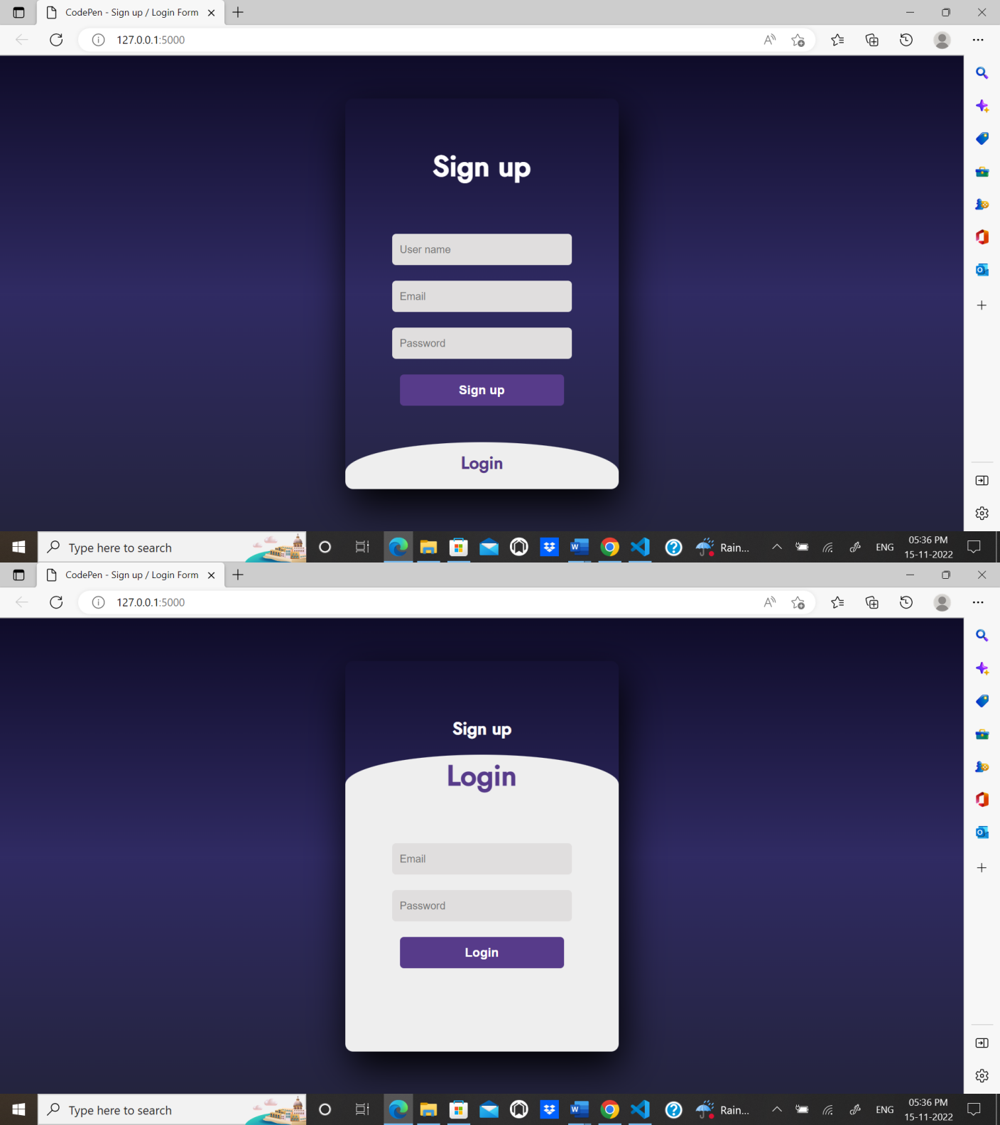

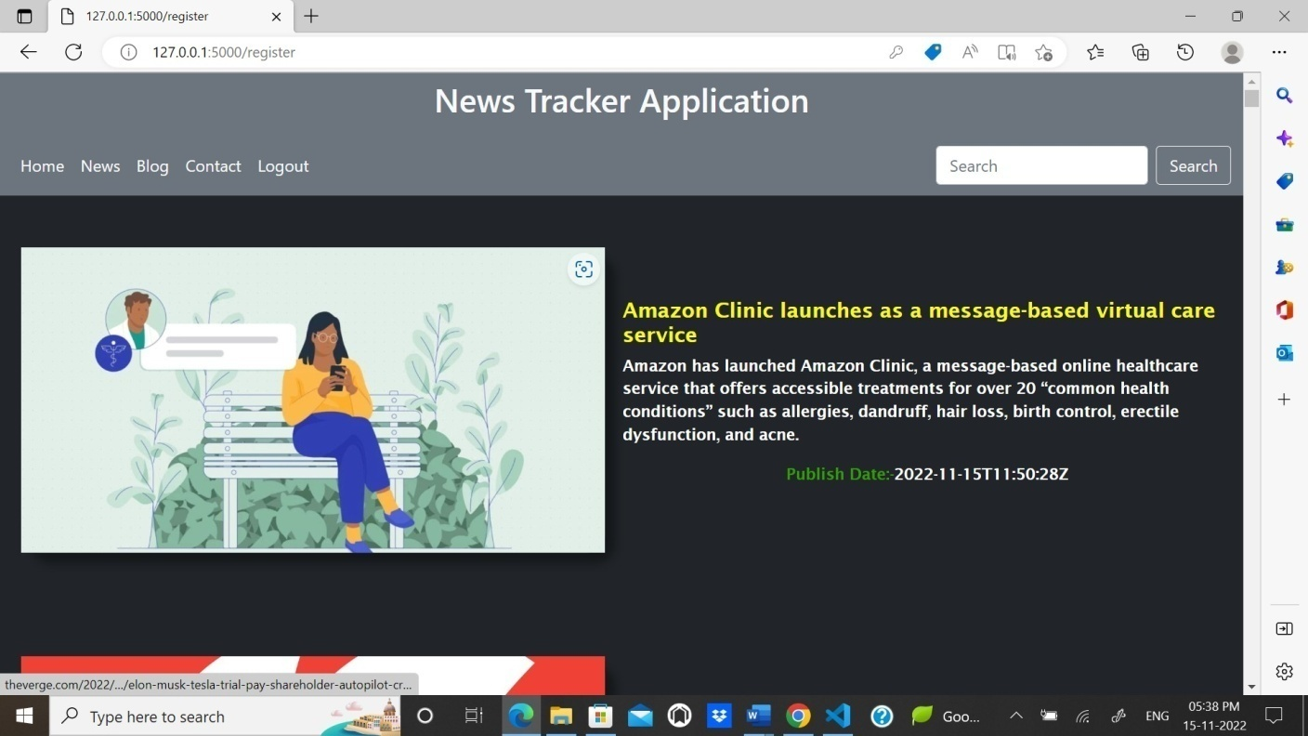



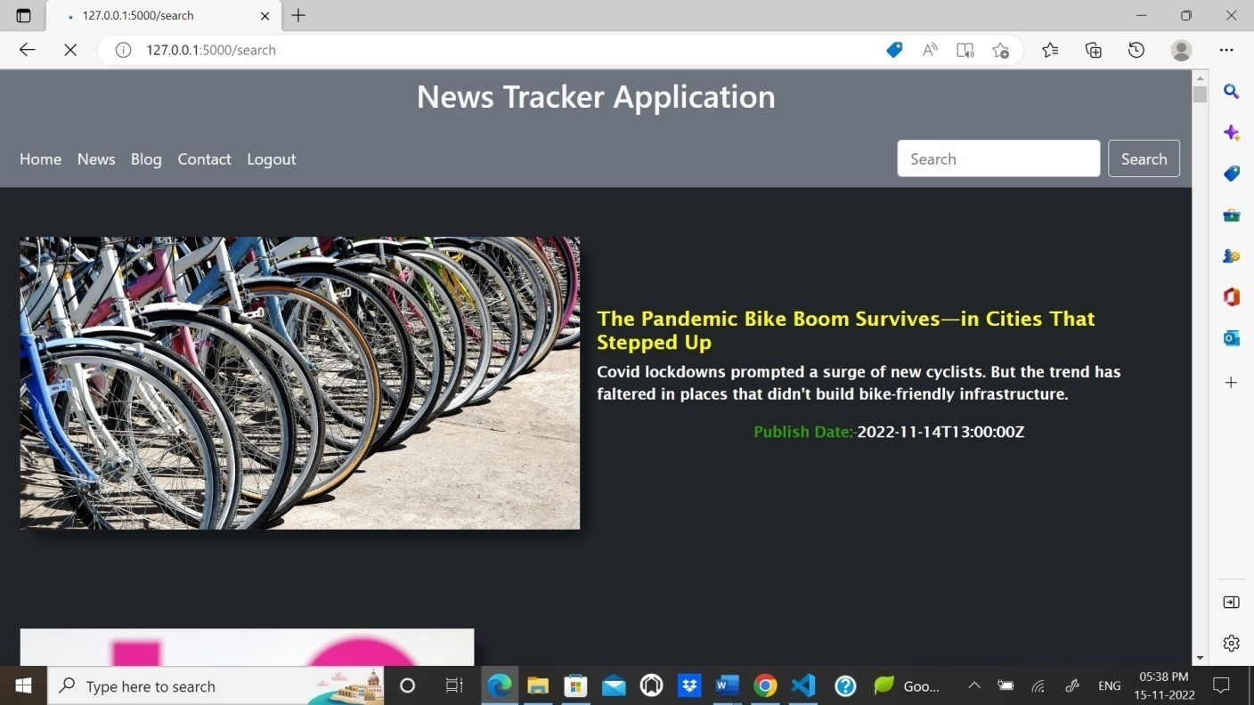

1. **ADVANTAGES**
2. All trending news will be displayed in a orderly manner.
3. We can costomize the topic which we are interested and make them display
4. The user experience are quit simple and friendly

# DISADVANTAGES

* 1. Same news which is published in different websites can be displayed.
  2. Delay response of news api can make the news collapse.

# CONCLUSION

Thus the projected using IBM CLOUD is tested,verified and executed successfully.

# Future scope

In future, we planned to implement this project in large scale which will be helpful and used by all the people.

# APPENDIX

**13.1.**Source Code Home.html

<!DOCTYPE html>

<html lang="en">

<head>

<meta charset="UTF-8">

<meta http-equiv="X-UA-Compatible" content="IE=edge">

<meta name="viewport" content="width=device-width, initial-scale=1.0">

<link rel="stylesheet" href="{{url_for('static', filename='css/style.css')}}">

<link rel="preconnect" href="https://fonts.googleapis.com">

<link rel="icon" href="{{url_for('static', filename='img/logo.png')}}">

<link href="https://fonts.googleapis.com/icon?family=Material+Icons" rel="stylesheet">

<title>{% block title %}{% endblock %}</title>

<link href="[https://cdn.jsdelivr.net/npm/bootstrap@5.0.2/dist/css/bootstrap.min.css](https://cdn.jsdelivr.net/npm/bootstrap%405.0.2/dist/css/bootstrap.min.css)" rel="stylesheet" integrity="sha384- EVSTQN3/azprG1Anm3QDgpJLIm9Nao0Yz1ztcQTwFspd3yD65VohhpuuCOmLASjC" crossorigin="anonymous">

</head>

<body>

<nav class="bg-secondary">

<h2 class="logo text-light">News Tracker Application</h2>

<!-- <ul class= "menu">

<li class="nav-items"><a href='/'>Home</a></li>

<li class="nav-items"><a href='/'>News</a></li>

<li class="nav-items"><a href='/'>Blogs</a></li>

<li class="nav-items"><a href='/'>Contact</a></li>

</ul> -->

</nav>

<nav class="navbar navbar-expand-lg bg-secondary">

<div class="container-fluid">

<!-- <h2>News Tracker Application</h2> -->

<!-- <button class="navbar-toggler" type="button" data-bs-toggle="collapse" data-bs- target="#navbarSupportedContent" aria-controls="navbarSupportedContent" aria-expanded="false" aria- label="Toggle navigation">

<span class="navbar-toggler-icon"></span>

</button> -->

<div class="collapse navbar-collapse" id="navbarSupportedContent">

<ul class="navbar-nav me-auto mb-2 mb-lg-0">

<li class="nav-item">

<a class="nav-link active text-light" aria-current="page" href="#">Home</a>

</li>

<li class="nav-item">

<a class="nav-link text-light" href="#">News</a>

</li>

<li class="nav-item">

<a class="nav-link text-light" href="#">Blog</a>

</li>

<li class="nav-item" role="contact">

<a class="nav-link text-light" href="/contact">Contact</a>

</li>

<li class="nav-item" rol="logout" >

<a class="nav-link text-light" href="/">Logout</a>

</li>

</ul>

<form class="d-flex" role="search" action = "/search" method = "post">

<input class="form-control me-2" type="search" placeholder="Search" aria-label="Search" name = "nm">

<button class="btn btn-outline-light" type="submit">Search</button>

</form>

</div>

</div>

</nav>

<section id="main" class="bg-dark">

<!-- <form action = "/search" method = "post">

<p><input type = "text" name = "nm" /></p>

<p><input type = "submit" value = "submit" /></p>

</form> -->

<!-- <div class="banner"><img src="https://t4.ftcdn.net/jpg/03/37/92/49/360_F_337924964_fF6I0iZkv9lvoIEn71f0OsgawArIPPDu.jpg ">

</div> -->

<!-- <div class = "head">TODAY'S TOP HEADLINES</div>

{% for title,desc,img,p_date,url in contents %}

<div class="wrapper">

<div class="item"><a href="{{url}}"><img src="{{img}}"></a></div>

<div class = "c-box">

<div class="content"><a href="{{url}}"><h2>{{title}}</h2></a></div>

<div class="content"><a href="{{url}}"><p>{{desc}}</p></a></div>

<div class="content"><p style="color:rgb(77, 255, 0);">Publish Date:-

</p><p>{{p_date}}</p></div>

</div>

</div>

{% endfor %} -->

{% for title,desc,img,p_date,url in all %}

<div class="wrapper">

<div class="item"><a href="{{url}}"><img src="{{img}}"></a></div>

<div class = "c-box">

<div class="content"><a href="{{url}}"><h2>{{title}}</h2></a></div>

<div class="content"><p>{{desc}}</p></div>

<div class="content"><p style="color:rgb(48, 158, 0);">Publish Date:- </p><p> {{p_date}}

</p></div>

</div>

</div>

{% endfor %}

</section>

<script src="[https://cdn.jsdelivr.net/npm/@popperjs/core@2.9.2/dist/umd/popper.min.js](https://cdn.jsdelivr.net/npm/%40popperjs/core%402.9.2/dist/umd/popper.min.js)" integrity="sha384- IQsoLXl5PILFhosVNubq5LC7Qb9DXgDA9i+tQ8Zj3iwWAwPtgFTxbJ8NT4GN1R8p" crossorigin="anonymous"></script>

<script src="[https://cdn.jsdelivr.net/npm/bootstrap@5.0.2/dist/js/bootstrap.min.js](https://cdn.jsdelivr.net/npm/bootstrap%405.0.2/dist/js/bootstrap.min.js)" integrity="sha384- cVKIPhGWiC2Al4u+LWgxfKTRIcfu0JTxR+EQDz/bgldoEyl4H0zUF0QKbrJ0EcQF" crossorigin="anonymous"></script>

</body>

</html>

# Index.html

<!DOCTYPE html>

<html lang="en" >

<head>

<meta charset="UTF-8">

<title>CodePen - Sign up / Login Form</title>

<link rel="stylesheet" href="{{url_for('static', filename='css/style2.css')}}">

</head>

<body>

<!-- partial:index.partial.html -->

<!DOCTYPE html>

<html>

<head>

<title>Slide Navbar</title>

<link rel="stylesheet" href="{{url_for('static', filename='css/style2.css')}}">

<link href="[https://fonts.googleapis.com/css2?family=Jost:wght@500&display=swap](https://fonts.googleapis.com/css2?family=Jost%3Awght%40500&display=swap)" rel="stylesheet">

</head>

<body>

<div class="main">

<input type="checkbox" id="chk" aria-hidden="true">

required="">

<div class="signup">

<form action = "/register" method="post">

<label for="chk" aria-hidden="true">Sign up</label>

<input type="text" name="un" placeholder="User name"

required=""> required="">

</div>

<input type="email" name="ue" placeholder="Email"

<input type="password" name="up" placeholder="Password"

<button type="submit">Sign up</button>

</form>

required=""> required="">

<div class="login">

<form action = "/login" method="post">

<label for="chk" aria-hidden="true">Login</label>

<input type="email" name="email" placeholder="Email"

<input type="password" name="pswd" placeholder="Password"

<button type="submit">Login</button>

</form>

</div>

</body>

</html>

<!-- partial -->

</body>

</html>

# Contact.html

<!DOCTYPE html>

<html lang="en">

<head>

</div>

<meta charset="UTF-8">

<meta http-equiv="X-UA-Compatible" content="IE=edge">

<meta name="viewport" content="width=device-width, initial-scale=1.0">

<title>Document</title>

<link href="[https://cdn.jsdelivr.net/npm/bootstrap@5.0.2/dist/css/bootstrap.min.css](https://cdn.jsdelivr.net/npm/bootstrap%405.0.2/dist/css/bootstrap.min.css)" rel="stylesheet" integrity="sha384- EVSTQN3/azprG1Anm3QDgpJLIm9Nao0Yz1ztcQTwFspd3yD65VohhpuuCOmLASjC" crossorigin="anonymous">

</head>

<body>

<div class='h-100 d-flex align-items-center justify-content-center'>

<table class="table table-bordered table-dark">

<tr>

<th scope="col">Team Member</th>

<th scope="col">Contact(Click the Symbol)</th>

</tr>

<tr>

<td>Devipriya S</td>

<td>

<a href="https://[www.linkedin.com/in/devi-priya-s5154711b3](http://www.linkedin.com/in/devi-priya-s5154711b3)"><svg xmlns="<http://www.w3.org/2000/svg>" width="16" height="16" fill="currentColor" class="bi bi-linkedin" viewBox="0 0 16 16">

<path d="M0 1.146C0 .513.526 0 1.175 0h13.65C15.474 0 16 .513 16 1.146v13.708c0 .633-

.526 1.146-1.175 1.146H1.175C.526 16 0 15.487 0 14.854V1.146zm4.943

12.248V6.169H2.542v7.225h2.401zm-1.2-8.212c.837 0 1.358-.554 1.358-1.248-.015-.709-.52-1.248-

1.342-1.248-.822 0-1.359.54-1.359 1.248 0 .694.521 1.248 1.327 1.248h.016zm4.908 8.212V9.359c0-

.216.016-.432.08-.586.173-.431.568-.878 1.232-.878.869 0 1.216.662 1.216 1.634v3.865h2.401V9.25c0-

2.22-1.184-3.252-2.764-3.252-1.274 0-1.845.7-2.165 1.193v.025h-.016a5.54 5.54 0 0 1 .016-

.025V6.169h-2.4c.03.678 0 7.225 0 7.225h2.4z"/>

</svg>

</a>

</td>

</tr>

<tr>

<td>Anusuya R</td>

<td>

<a href="https://[www.linkedin.com/in/anusuya-r-706b40214](http://www.linkedin.com/in/anusuya-r-706b40214)"><svg xmlns="<http://www.w3.org/2000/svg>" width="16" height="16" fill="currentColor" class="bi bi-linkedin" viewBox="0 0 16 16">

<path d="M0 1.146C0 .513.526 0 1.175 0h13.65C15.474 0 16 .513 16 1.146v13.708c0 .633-

.526 1.146-1.175 1.146H1.175C.526 16 0 15.487 0 14.854V1.146zm4.943

12.248V6.169H2.542v7.225h2.401zm-1.2-8.212c.837 0 1.358-.554 1.358-1.248-.015-.709-.52-1.248-

1.342-1.248-.822 0-1.359.54-1.359 1.248 0 .694.521 1.248 1.327 1.248h.016zm4.908 8.212V9.359c0-

.216.016-.432.08-.586.173-.431.568-.878 1.232-.878.869 0 1.216.662 1.216 1.634v3.865h2.401V9.25c0-

2.22-1.184-3.252-2.764-3.252-1.274 0-1.845.7-2.165 1.193v.025h-.016a5.54 5.54 0 0 1 .016-

.025V6.169h-2.4c.03.678 0 7.225 0 7.225h2.4z"/>

</svg>

</a>

</td>

</tr>

<tr>

<td>Anusuya R</td>

<td>

<a href="https://[www.linkedin.com/in/anusuya-r-b978a11ab](http://www.linkedin.com/in/anusuya-r-b978a11ab)"><svg xmlns="<http://www.w3.org/2000/svg>" width="16" height="16" fill="currentColor" class="bi bi-linkedin"

viewBox="0 0 16 16">

<path d="M0 1.146C0 .513.526 0 1.175 0h13.65C15.474 0 16 .513 16 1.146v13.708c0 .633-

.526 1.146-1.175 1.146H1.175C.526 16 0 15.487 0 14.854V1.146zm4.943

12.248V6.169H2.542v7.225h2.401zm-1.2-8.212c.837 0 1.358-.554 1.358-1.248-.015-.709-.52-1.248-

1.342-1.248-.822 0-1.359.54-1.359 1.248 0 .694.521 1.248 1.327 1.248h.016zm4.908 8.212V9.359c0-

.216.016-.432.08-.586.173-.431.568-.878 1.232-.878.869 0 1.216.662 1.216 1.634v3.865h2.401V9.25c0-

2.22-1.184-3.252-2.764-3.252-1.274 0-1.845.7-2.165 1.193v.025h-.016a5.54 5.54 0 0 1 .016-

.025V6.169h-2.4c.03.678 0 7.225 0 7.225h2.4z"/>

</svg>

</a>

</td>

</tr>

<tr>

<td>Gowsalya P </td>

<td>

<a href="https://[www.linkedin.com/in/gowsalya-p-97b405184](http://www.linkedin.com/in/gowsalya-p-97b405184)"><svg xmlns="<http://www.w3.org/2000/svg>" width="16" height="16" fill="currentColor" class="bi bi-linkedin" viewBox="0 0 16 16">

<path d="M0 1.146C0 .513.526 0 1.175 0h13.65C15.474 0 16 .513 16 1.146v13.708c0 .633-

.526 1.146-1.175 1.146H1.175C.526 16 0 15.487 0 14.854V1.146zm4.943

12.248V6.169H2.542v7.225h2.401zm-1.2-8.212c.837 0 1.358-.554 1.358-1.248-.015-.709-.52-1.248-

1.342-1.248-.822 0-1.359.54-1.359 1.248 0 .694.521 1.248 1.327 1.248h.016zm4.908 8.212V9.359c0-

.216.016-.432.08-.586.173-.431.568-.878 1.232-.878.869 0 1.216.662 1.216 1.634v3.865h2.401V9.25c0-

2.22-1.184-3.252-2.764-3.252-1.274 0-1.845.7-2.165 1.193v.025h-.016a5.54 5.54 0 0 1 .016-

.025V6.169h-2.4c.03.678 0 7.225 0 7.225h2.4z"/>

</svg>

</a>

</td>

</tr>

</table>

</div>

<script src="[https://cdn.jsdelivr.net/npm/@popperjs/core@2.9.2/dist/umd/popper.min.js](https://cdn.jsdelivr.net/npm/%40popperjs/core%402.9.2/dist/umd/popper.min.js)"

integrity="sha384- IQsoLXl5PILFhosVNubq5LC7Qb9DXgDA9i+tQ8Zj3iwWAwPtgFTxbJ8NT4GN1R8p" crossorigin="anonymous"></script>

<script src="[https://cdn.jsdelivr.net/npm/bootstrap@5.0.2/dist/js/bootstrap.min.js](https://cdn.jsdelivr.net/npm/bootstrap%405.0.2/dist/js/bootstrap.min.js)" integrity="sha384- cVKIPhGWiC2Al4u+LWgxfKTRIcfu0JTxR+EQDz/bgldoEyl4H0zUF0QKbrJ0EcQF" crossorigin="anonymous"></script>

</body>

</html> **Style.css** body {

margin: 0px; padding: 0px;

background-color: rgb(69, 54, 54);

}

* {

box-sizing: border-box;

}

ul {

list-style: none;

}

a {

text-decoration: none !important;

}

nav {

min-height: 60px; width: 100%;

/* background-color: red; */

/* border-top: 1px solid black !important; */ position: relative;

display: flex;

justify-content: space-around; align-items: center;

flex-flow: row wrap;

}

.logo h2 {

font-size: 30px; font-weight: bold;

font-family: -apple-system, BlinkMacSystemFont, 'Segoe UI', Roboto, Oxygen, Ubuntu, Cantarell, 'Open Sans', 'Helvetica Neue', sans-serif;

color: white !important;

text-decoration: none !important; letter-spacing: 1px;

}

nav .menu { display: flex;

flex-flow: row wrap; justify-content: center; align-items: center;

}

nav .menu li a { height: 35px;

line-height: 30px; display:flex ;

text-transform: uppercase; align-items: center; padding: 0px 22px;

font-size: 15px; font-weight: bold; color: white;

font-family: 'Poppins', sans-serif; letter-spacing: 1px;

}

nav .menu li a:hover { color: black; background-color:white; border-radius: 20px;

}

#main {

/* padding-top: 98px; */

}

.banner {

height: 620px; width: 100%; display: flex;

flex-wrap: column; justify-content: center; align-items: center; background-color: black;

border: 1px solid rgb(98, 4, 4);

}

.banner img { height: 100%;

width: 100%; padding: 2px;

}

.head-git{ height: 40px; width: 100%;

justify-content: center; align-items: center;

background-color: rgb(250, 244, 244); display: flex;

flex-flow: row; margin-bottom: 5px;

}

.head-git h2 { font-size: 18px;

font-family: 'Gill Sans', 'Gill Sans MT', Calibri, 'Trebuchet MS', sans-serif; color:black;

}

.head-git h2 a {

text-decoration: none ; color:blue;

font-size: 23px;

}

.head-git h2 a:hover { color:rgb(211, 47, 41);

background-color: beige;

}

.nav-link { height: 100%;

width: 100%; color: black;

}

.head {

height: 50px; width: 100%; display: flex;

align-items: center; justify-content: center; color: white;

font-size: 30px; font-weight: bold;

font-family:'Times New Roman', Times, serif; padding-left: 20px;

padding-top: 10px;

}

.wrapper { height: 400px; width: 100%; display: flex;

align-items: center; padding: 10px;

justify-content: space-between;

/* background-color: rgb(68, 47, 47); */

}

.wrapper .item { height: 300px; min-width: 30%;

border-radius: 20px; margin: 10px;

box-shadow: 10px 10px 10px rgba(0, 0, 0, 0.4); padding: 0.5px;

flex-flow: column wrap; border-bottom: 1px white;

}

.wrapper .item img { height: 100%;

width: 100%;

}

.c-box {

height: content; max-width: 50%; display: flex;

align-items: center;

padding: 10px; flex-flow: column; padding: 1px;

}

.c-box .content { height: content; min-width: 30%; display: flex;

align-items: center; flex-flow: row wrap;

}

.c-box .content p { color: #fff;

font-size: 15px; font-weight: bold;

font-family: 'Lucida Sans', 'Lucida Sans Regular', 'Lucida Grande', 'Lucida Sans Unicode', Geneva, Verdana, sans-serif;

}

.c-box .content h2 { color: yellow; font-size: 20px; font-weight: bold;

font-family: 'Lucida Sans', 'Lucida Sans Regular', 'Lucida Grande', 'Lucida Sans Unicode', Geneva, Verdana, sans-serif;

}

.head-f{

height: 40px; width: 100%;

justify-content: center; align-items: center;

border-top: 2px solid black; background-color: yellow; display: flex;

flex-flow: column;

}

.head-f h2 {

font-size: 15px;

font-family: 'Gill Sans', 'Gill Sans MT', Calibri, 'Trebuchet MS', sans-serif; color:black;

}

# Style2.css

body{

margin: 0;

padding: 0; display: flex;

justify-content: center; align-items: center; min-height: 100vh;

}

.main{

font-family: 'Jost', sans-serif;

background: linear-gradient(to bottom, #0f0c29, #302b63, #24243e);

width: 350px; height: 500px; background: red; overflow: hidden;

background: url("https://doc-08-2c-

docs.googleusercontent.com/docs/securesc/68c90smiglihng9534mvqmq1946dmis5/fo0picsp1nhiucmc0l2 5s29respgpr4j/1631524275000/03522360960922298374/03522360960922298374/1Sx0jhdpEpnNIydS4r

nN4kHSJtU1EyWka?e=view&authuser=0&nonce=gcrocepgbb17m&user=03522360960922298374&has h=tfhgbs86ka6divo3llbvp93mg4csvb38") no-repeat center/ cover;

border-radius: 10px;

box-shadow: 5px 20px 50px #000;

}

#chk{

}

display: none;

.signup{

position: relative; width:100%; height: 100%;

}

label{

}

input{

}

button{

color: #fff;

font-size: 2.3em; justify--weighsor: pointer;

transition: .5s ease-in-out;

width: 60%; height: 20px;

background: #e0dede; justify-content: center; display: flex;

margin: 20px auto; padding: 10px; border: none; outline: none; border-radius: 5px;

width: 60%;

height: 40px; margin: 10px auto;

justify-content: center; display: block;

color: #fff; background: #573b8a; font-size: 1em;

font-weight: bold; margin-top: 20px; outline: none; border: none; border-radius: 5px;

transition: .2s ease-in; cursor: pointer;

}

button:hover{

background: #6d44b8;

}

.login{

}

height: 460px; background: #eee;

border-radius: 60% / 10%; transform: translateY(-180px); transition: .8s ease-in-out;

.login label{

color: #573b8a; transform: scale(.6);

}

#chk:checked ~ .login{

transform: translateY(-500px);

}

#chk:checked ~ .login label{ transform: scale(1);

}

#chk:checked ~ .signup label{ transform: scale(.6);

}

# app.py

from cloudant.client import Cloudant

from cloudant.error import CloudantException from cloudant.result import Result, ResultByKey from flask import Flask, render_template, request from newsapi import NewsApiClient

serviceUsername = "50ab9a31-993d-4eaf-abf1-21c6f737b08c-bluemix"

servicePassword = "6864bc1c41f5701310846a0a80700140c138e7c82b8c7f678ce5ab877f8b90b9"

serviceURL = "https://50ab9a31-993d-4eaf-abf1-21c6f737b08c- bluemix:6864bc1c41f5701310846a0a80700140c138e7c82b8c7f678ce5ab877f8b90b9@50ab9a31-993d- 4eaf-abf1-21c6f737b08c-bluemix.cloudantnosqldb.appdomain.cloud"

client = Cloudant(serviceUsername, servicePassword, url=serviceURL) client.connect()

app = Flask( name )

@app.route("/news") def news():

api_key = '4f625485702d4929a546bcf4eb9d5c79' newsapi = NewsApiClient(api_key=api_key)

top_headlines = newsapi.get_top_headlines(sources = "the-verge") all_articles = newsapi.get_everything(sources = "the-verge")

t_articles = top_headlines['articles'] a_articles = all_articles['articles']

news = [] desc = [] img = [] p_date = [] url = []

for i in range (len(t_articles)): main_article = t_articles[i]

news.append(main_article['title']) desc.append(main_article['description']) img.append(main_article['urlToImage']) p_date.append(main_article['publishedAt']) url.append(main_article['url'])

contents = zip( news,desc,img,p_date,url) news_all = []

desc_all = []

img_all = [] p_date_all = [] url_all = []

for j in range(len(a_articles)): main_all_articles = a_articles[j]

news_all.append(main_all_articles['title'])

desc_all.append(main_all_articles['description']) img_all.append(main_all_articles['urlToImage']) p_date_all.append(main_all_articles['publishedAt']) url_all.append(main_article['url'])

all = zip( news_all,desc_all,img_all,p_date_all,url_all) return render_template('home.html',all = all)

@app.route("/search",methods = ['POST', 'GET']) def searchFunct():

inputText = request.form['nm']

api_key = '4f625485702d4929a546bcf4eb9d5c79' newsapi = NewsApiClient(api_key=api_key)

top_headlines = newsapi.get_top_headlines(sources="bbc-news") all_articles = newsapi.get_everything(q=inputText)

t_articles = top_headlines['articles'] a_articles = all_articles['articles']

news = [] desc = [] img = [] p_date = [] url = []

for i in range (len(t_articles)): main_article = t_articles[i]

news.append(main_article['title']) desc.append(main_article['description']) img.append(main_article['urlToImage']) p_date.append(main_article['publishedAt']) url.append(main_article['url'])

contents = zip( news,desc,img,p_date,url) news_all = []

desc_all = []

img_all = [] p_date_all = [] url_all = []

for j in range(len(a_articles)): main_all_articles = a_articles[j]

news_all.append(main_all_articles['title']) desc_all.append(main_all_articles['description']) img_all.append(main_all_articles['urlToImage']) p_date_all.append(main_all_articles['publishedAt']) url_all.append(main_article['url'])

all = zip( news_all,desc_all,img_all,p_date_all,url_all) return render_template('home.html', all = all)

def addNewUser(userName,userEmail,userPassword): jsondata = {}

jsondata["userName"] = str(userName) jsondata["userEmail"] = str(userEmail) jsondata["userPassword"] = str(userPassword)

myDataBase = client['database1']

newDocument = myDataBase.create_document(jsondata)

def authenticate(userName,userEmail): myDataBase = client['database1']

result_collection = Result(myDataBase.all_docs, include_docs=True) for data in result_collection:

if data['doc']['userName'] == str(userName): return True

if data['doc']['userEmail'] == str(userEmail): return True

return False

def authenticateLogin(userEmail,userPassword): myDataBase = client['database1']

result_collection = Result(myDataBase.all_docs, include_docs=True)

for data in result_collection:

if data['doc']['userPassword'] == str(userPassword) and data['doc']['userEmail'] == str(userEmail): return True

return False

@app.route("/login",methods = ['POST', 'GET']) def loginUser():

userEmail = request.form.get("email") userPassword = request.form.get("pswd")

if(authenticateLogin(userEmail,userPassword)):

return news()

return render_template("index.html")

@app.route("/register",methods = ['POST', 'GET']) def registerUserData():

userName = request.form.get("un") userEmail = request.form.get("ue") userPassword = request.form.get("up")

print(userEmail,userName,userPassword) if(authenticate(userName=userName,userEmail=userEmail)):

return render_template("index.html") addNewUser(userName,userEmail,userPassword) return news()

@app.route("/") def home():

return render_template("index.html")

@app.route("/contact") def hh():

return render_template("contact.html")

if name == ' main ': app.run(debug=True)

# GitHub :

https://github.com/IBM-EPBL/IBM-Project-36465-1660297727

# Project Demo Link: https://github.com/IBM-EPBL/IBM-Project-36465-1660297727/blob/main/News%20Tracker/Final%20deliveries/PNT2022TMID41776_News%20TrackerApplication_video_.mp4